Same Pronunciation

🔹 What is Same Pronunciation
# Source: Chatgpt (GPT-4-turbo) at [8/1/2025]
(Also called: Homographs that are Homophones)
These are homographs—words spelled the same—that also share the same pronunciation, but have different meanings (and often different grammatical roles).
These words are both homographs and homophones, but not necessarily homonyms (true) unless the meanings are unrelated.

🧱 Key Features
# Source: Chatgpt (GPT-4-turbo) at [8/1/2025]
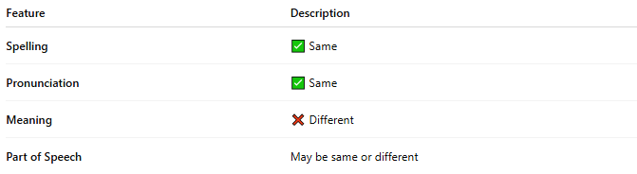
Feature | Description
Spelling | ✅ Same
Pronunciation | ✅ Same
Meaning | ❌ Different
Part of Speech | May be same or different

📝 Examples
# Source: Chatgpt (GPT-4-turbo) at [8/1/2025]
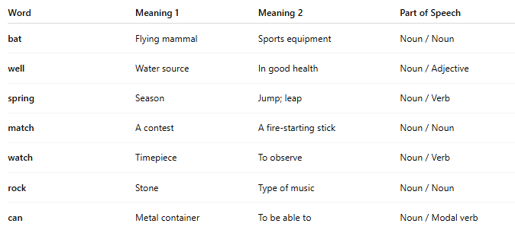
Word | Meaning 1 | Meaning 2 | Part of Speech
bat | Flying mammal | Sports equipment | Noun / Noun
well | Water source | In good health | Noun / Adjective
spring | Season | Jump; leap | Noun / Verb
match | A contest | A fire-starting stick | Noun / Noun
watch | Timepiece | To observe | Noun / Verb
rock | Stone | Type of music | Noun / Noun
can | Metal container | To be able to | Noun / Modal verb

🧭 Comparison Table
# Source: Chatgpt (GPT-4-turbo) at [8/1/2025]
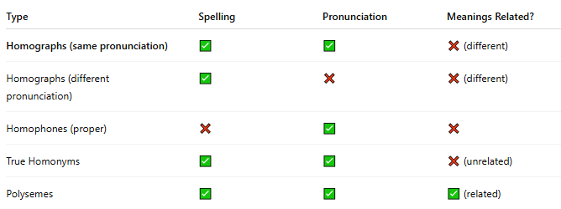
Type | Spelling | Pronunciation | Meanings Related?
Homographs (same pronunciation) | ✅ | ✅ | ❌ (different)
Homographs (different pronunciation) | ✅ | ❌ | ❌ (different)
Homophones (proper) | ❌ | ✅ | ❌
True Homonyms | ✅ | ✅ | ❌ (unrelated)
Polysemes | ✅ | ✅ | ✅ (related)

🧠 Notes
# Source: Chatgpt (GPT-4-turbo) at [8/1/2025]
- If the meanings are unrelated, they may also qualify as true homonyms.
- If meanings are conceptually related, they may be polysemes instead.

